

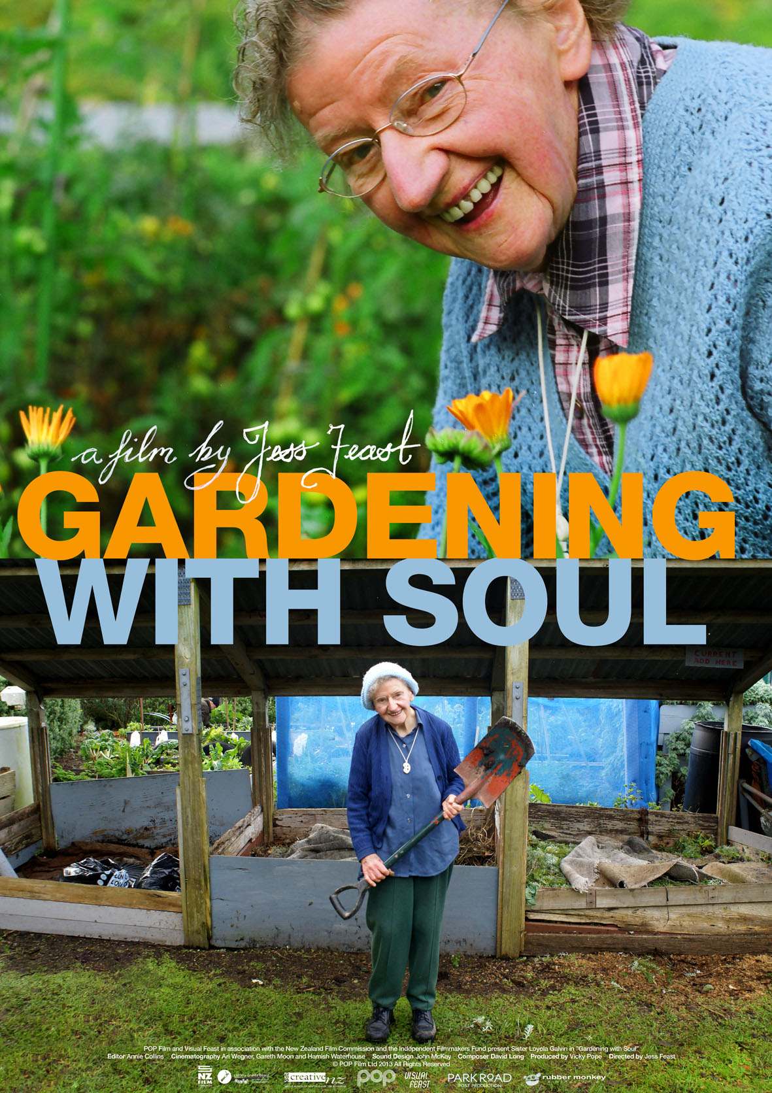

*WINNER-BEST DOCUMENTARY-NZ FILM AWARDS 2013*
*HONORABLE MENTION: ADELAIDE DOCWEEK 2014*

“What a film!....I’ve never seen anything so warm-hearted or inspiring in my life…You will not have a better time at the cinema this year”

GRAEME TUCKETT-RADIO NZ NATIONAL

**** 4.5 stars-“A beautifully shot gem about an extraordinary woman who has touched many lives and hearts”

Sarah Lang-Herald on Sunday

**** 4 stars-“ A film comes along very occasionally that makes you want to call your mum and arrange to go and see it again together. This is one of those films…..Heartwarming and amusing”

Francesca Rudkin-Next Magazine

**** 4 stars “A rare and special film, impossible not to admire, respect and be moved by. Go and see it”

-DOMINION POST

"...should you find yourself wanting your faith in humanity buoyed up a little, may I direct you to 'Gardening with Soul', a lovely, gentle study of a year in the life of Sister Loyola, the 90-year-old chief gardener of Wellington's Home of Compassion.”

DAVID LARSEN-THE LISTENER

GARDENING WITH SOUL
GENRE: Documentary
LENGTH: 100 MINS
AWARDS: Best Documentary-NZ Film Awards 2013
Honorable Mention: Adelaide Docweek 2014
FACEBOOK/WEBSITE: www.gardeningwithsoul.org
https://www.facebook.com/GardeningWithSoul
RATING: G-suitable for general audiences
U.S. PRESS CONTACT: Film Ignite
Contact: Amanda Pomeroy
Amanda@filmignite.com /310.895.8522
NZ DISTRIBUTOR: POP Film Ltd
NZ FESTIVAL PREMIERE: 27 July 2013
NZ NATIONAL RELEASE DATE: 12 Sept 2013
AUSTRALIAN DISTRIBUTOR: Hi Gloss Entertainment
Contact: Simon Killen
simon@higlossentertainment.com.au
+61 438 563 783
SHOOTING FORMAT/RATIO: Canon 5D/ 16:9
LOCATIONS: Home of Compassion, Island Bay, Wellington
PRODUCTION COMPANY: POP Film Ltd and Visual Feast
PRODUCER CONTACT: vickypope@me.com
CAST: Sister Loyola Galvin
DIRECTOR: Jess Feast
PRODUCER: Vicky Pope
EDITOR: Annie Collins
CINEMATOGRAPHY: Ari Wegner, Gareth Moon and Hamish Waterhouse
SOUND DESIGN: John McKay
COMPOSER: David Long

90-year-old nun Sister Loyola Galvin shares insights on faith, aging, compassion and compost during a year in her garden.

Short synopsis
Gardening with Soul is a feature length documentary following a year in the garden with 90-year-old Sister Loyola Galvin. Sister Loyola's optimism is infectious and it's fed every day by her love of gardening. Themes of faith, aging and compassion sit alongside the practicalities of community life, issues within the Catholic Church and the importance of good compost in this intimate, funny and moving portrait of a woman approaching the end of her life.

Long synopsis
Sister Loyola is one of the liveliest nonagenarians you could ever meet.
As the main gardener at the Home of Compassion in Island Bay, Wellington, her daily tasks include heavy lifting alongside vigorous spade and wheelbarrow work, which she sometimes performs on crutches. Loyola and the other Sisters of Compassion follow the vision of Mother Aubert to ‘meet the needs of the oppressed and powerless in their communities’.
Filmmaker Jess Feast (Cowboys and Communists) has been following Sister Loyola over the last year, charting her journey through the seasons which included her 90th birthday. Through her garden, we begin to understand Loyola’s commitment to nurture all living things, especially those which ‘don’t get a good start’. From her early work as a nurse with sick or stillborn babies, to her role as a nun raising children with disabilities, we see Loyola’s incredible energy and faith in her God to carry her through the difficult times.
The lively, beautifully shot documentary (edited by Annie Collins) is filmed almost entirely in this small community on the southern coast of Wellington. With music by local musician David Long, and full of the sea- and garden-scapes that have informed Loyola’s life, Gardening with Soul uncovers a local legend and her community for the wider world. It is a conceptual triumph for Feast. Any belief we might harbour that becoming a nun is avoiding the real world is turned firmly on its head as we witness this extraordinary soul steer a sharp course through all weathers, trying to shine love on everything she sees.
- Jo Randerson (NZ International Film Festival)

DIRECTOR’S STATEMENT
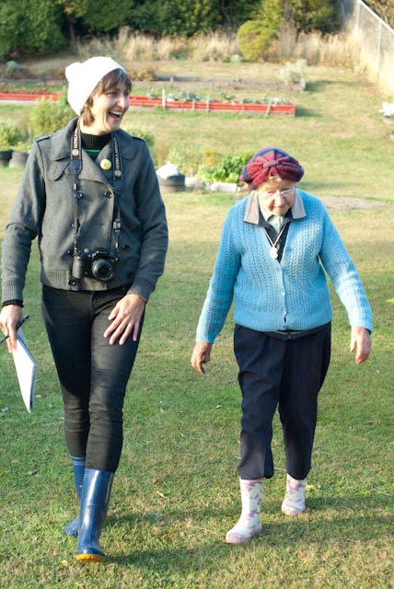
The journey of the film ‘Gardening with Soul’ began several years ago when I heard an interview with Sister Loyola Galvin on National Radio following her 2008 ‘Gardener of the Year’ win. She was immediately engaging as a person and seemed to me to embody that wonderful old wisdom held by my grandparents generation, wisdom that would soon be lost if not preserved properly. So I arranged to meet Sister Loyola and after a series of conversations was inspired to explore the idea of writing a book about her. But before I got too far along this track, I was sidetracked by a “small” film project that turned into a much larger one (as they tend to do).
Following a seasonal structure, I set out to film with Sister Loyola over a year. While mapping out her story with this metaphor in mind I also kept my options open, allowing room for things to grow and evolve, and just capturing what happened in her daily life. There is a rhythm to the garden, through the seasons and also through days. There is a patience too, a sense of time and change. The shoot also required patience, on both our parts, and this long-term approach to filming paid off in the genuine revelation of aging and also in the evolving intimacy between Sister Loyola and I.
As one of the growing number of New Zealanders who describe themselves as having “No Religion”, I was interested in how a person approaching the end of her life, who had spent much more time than most thinking about God and faith, would articulate her thoughts on the subject. I was interested in how someone so open-minded, well read and intelligent would interpret ideas and beliefs about which I was somewhat sceptical. I was also interested in how a strong woman felt about the institution that is the Catholic Church, given it’s male dominated power structures and it’s ongoing scandals and cover-ups.
Over the course of many conversations, I came to understand much more about the nature of faith, Sister Loyola’s motivations and choices.
Part of Sister Loyola’s charm is her commitment to the practical, the down to earth and the way she effortlessly connects the sacred and the profane, linking her learnings from the garden to her spiritual life. Her deep compassion is expressed in the way she deals with people and with plants.
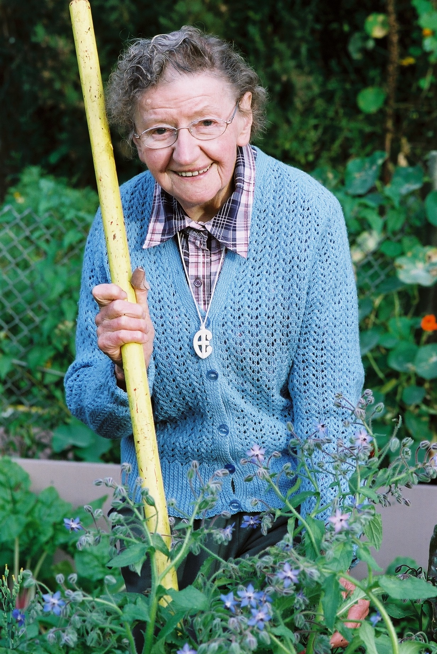
Alongside the interviews, watching Sister Loyola interact with those around her – her helper, David; members of the community garden; visitors to her own plot; the other sisters, brings her way of being to life.
Through the challenges of living a community life and the issues of reconciliation within the Catholic Church, and her own personal challenges, Sister Loyola’s strength comes from the message of compassion, passed down to the sisters from Mother Aubert, who founded the order in the 1860s. Mother Aubert has a subtle but continual presence through the film and may soon become New Zealand's first canonised saint.
Sister Loyola turned ninety during the course of the filming, and it was a rare privilege to hear the perspective of someone that age. Over the course of her life she has observed, and been a part of, massive social change. These changes are reflected in the role of the order and it’s current devolution (or evolution).
For Sister Loyola personally, her 90th year was a time of reflection, particularly on what she valued most as she looked back on her life. It was also a time when the reality of death came closer and, even for someone with such a strong faith, questions remain about what lies beyond. As always, her thoughts returned to the cycle of the garden.
I feel very lucky to have spent the time I did with Sister Loyola and I hope that the film we have made will help to share some of her humor, insights and inspiration to a wide audience.

Production notes
I wanted to begin the film in winter because of the idea of preparation that happens then and so we shot from June to June with a few extra pick ups in the six months following.
Prior to commencing, I gave birth to my first child who was five months when we began and has been a presence throughout the process – sometimes carried in a front pack on shoots and a source of joy for the Sisters while we were filming. Our producer Vicky Pope also had her first child during the filming process and I am now heavily pregnant with my second baby so it has been something of an ongoing theme! 'Gardening with Soul' has quite a strong focus on children and the importance of nurture so it really has felt like a case of life imitating art.
Because the filming process took place over such a long period, we ended up engaging the talents of several DOPs, all of whom contributed their own creative eye to the project. This meant it was even more important that the vision for the film was strong during both the shoot and the edit.
I was privileged to work with the very talented editor Annie Collins. It was our first experience working together and we both enjoyed the process immensely. Patience was also required for this part of the film making which took over 6 months. Annie's unique approach was a real eye opener for me in terms of documentary storytelling and while there was a strong structure in place during the filming (provided by the seasonal themes), the whole thing really came together in the edit. As always when viewing rushes, there are so many possible tangents to follow. When in doubt, our focus kept us close to the personal experiences of Sister Loyola. Therefore, the film is very much the portrait of one woman and this singularity allowed us to spend our onscreen time diving deeper, creating a journey towards intimacy and understanding of her life and faith.

ABOUT SISTER LOYOLA GALVIN
A frosty morning in Hawera, Taranaki in May 1922 saw my advent into life. A happy childhood with many pets and animals was interrupted by an accident at the age of 3 years, with serious damage to my left ankle, in which at the age of 10 years I developed Osteomylitis. This resulted in hospital stays and painful treatment for a further 4 years. During this period I fell in love with nurses and nursing, and the desire to follow that profession was born.
Because of my medical history, my first application to begin nursing training - 1941, Hawera Hospital - was declined. Two years later I had another go. Due to a recommendation of Dr Doris Gordon of Stratford, I was approved for training in Wellington, providing I passed the medical exam requirements. So in 1943 I applied again. When it came to the medical, at the very moment when it was my turn the examining doctor was called to the telephone–trouble had broken out with the Japanese Prisoners of War of at the Wairarapa camp. It was an emergency and all available doctors were needed to deal with the casualties. The doctor only gave me a cursory check before he left to attend the injured at Featherston. He did not look at my foot, or even read my notes, and I was given the OK! I went on to complete my training without any problems.
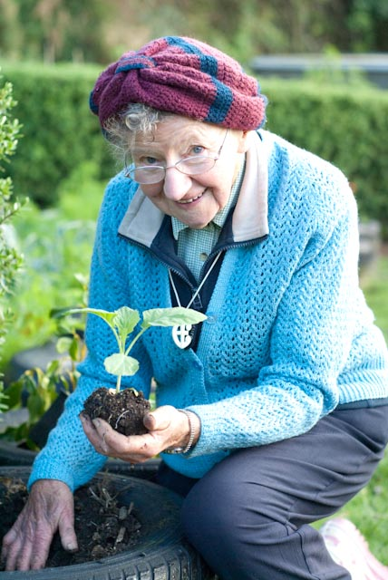
I nursed for two years in Wellington, and then for a time in my home town, Hawera. I had formed an attachment with a young soldier, who sadly did not return from the War. This led me to examine options for my future. In Wellington I had had contact with the Home of Compassion through a relative, and I was drawn to caring for disabled children. In 1947 I joined the congregation as a postulant.
For my first ten years in the order I worked in Compassion facilities in New Zealand, principally at Island Bay caring for babies and children, as well as doing duties in the geriatric section. Further children’s work followed in Australia at Broken Hill, and geriatric work at Wagga Wagga. Returning to New Zealand in 1963 I continued nursing in Compassion facilities in Timaru and Island Bay, as well as caring for unmarried mothers and babies in Auckland.
In 1979 I relieved a chaplain for 3 months at Wellington Hospital. I subsequently did chaplaincy training, leading to a full time chaplaincy position at the Hutt Hospital for 14 years. I was often called to support parents with new born disabled babies. Because of our philosophy which calls us to respond to ‘Need, not Creed’, I was available to all. Out of this grew my concern for the needs of parents of still-born babies. In 1988, due to efforts by 3 mothers, a midwife, and myself, ‘Still-Born Support’ was established at the Hutt Hospital. This is now a nation wide organisation. Among services offered are help with providing caskets, support for parents, and educative initiatives in the health profession.
Historically still-born babies were often buried without ceremony, mainly in unmarked graves. Many people had difficulty resolving their grief in these cases. After 7 years of lobbying, a memorial stone gifted by Glover Memorials was installed at the Taita cemetery in 1995. Since then, more such memorials have been established throughout New Zealand.
In 1995 my chaplaincy time ended, but I continued to be involved with Still-Birth Support. I also work in ministry to the poor and disabled, including refugees and migrants, in the community. When required I am available to Wesley Community Care for transport of the frail elderly. In latter years I developed an enthusiasm for conservation, and with the NZ Forest and Bird Society I regularly contributed my efforts to the re-forestation programme of Somes Island. In Island Bay there is always plenty of gardening to do at our own Home of Compassion. I also represent the congregation as a trustee with the neighbouring Tapu Te Ranga Marae.
In 1995 my chaplaincy time ended, but I continued to be involved with Still-Birth Support. I also worked in ministry to the poor and disabled, including refugees and migrants, in the community. When required I was available to Wesley Community Care for transport of the frail elderly. In latter years I developed an enthusiasm for conservation, and with the NZ Forest and Bird Society I regularly contributed my efforts to the re-forestation programme of Somes Island. In Island Bay there is always plenty of gardening to do at our own Home of Compassion. I also represent the congregation as a trustee with the neighbouring Tapu Te Ranga Marae.
In 1996 Sr Loyola was awarded the Queen’s Service Medal for Community Services. She was also named NZ Gardener of the Year in 2008-NZ Gardener Magazine’s annual accolade recognizing NZ’s unsung horticultural heroes who use their passion for gardening to give back to the community. The award recognized her work establishing a Common Ground Community Gardening scheme on an area of lawn at the Home of Compassion for allotment-style gardens for people in the area with no land to grow food.
Sources: http://compassion.org.nz
ABOUT SUZANNE AUBERT-FOUNDER OF THE SISTERS OF COMPASSION
Suzanne Aubert, also known as Mother Aubert, was born and raised in France. She was from a middle class family, but developed a great love for the poor by taking food to them. Her grandmother taught her that the face of Christ can be seen in the faces of the poor, and that it was a privilege to serve them.
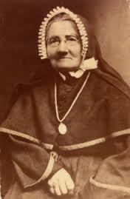
At the age of 19 Suzanne Aubert heard Bishop Pompallier speak in Lyon, and responded to his request for missionaries to go to New Zealand. When she left to board the whaling ship, her family thought she had gone to the funeral of family friend, the Cure’dArs. Her father had not allowed her to become a religious in her late teens, and by leaving home she was breaking the promise she had made to her father to stay at home until she was 25.
Pompallier taught Aubert and the other missionaries Maori on the way to New Zealand. Eventually she became fluent and wrote a Maori dictionary and prayer book.
In France Aubert had learnt chemistry and botany from a relative. When she arrived in New Zealand she used this knowledge to make remedies for healing. She eventually won the respect of the Maori people, who shared their own knowledge with her.
Under the guidance of the Sisters of Mercy, Aubert and the other French missionaries opened a school for Maori girls in Auckland. When Pompallier left Auckland, he also left behind financial difficulties and as a result the school was closed down. Although she had learnt English after learning Maori, Aubert did not want to work in an English school as she had come to New Zealand to work with Maori. So she moved to Hawkes Bay where she worked as a district nurse and catechist.
Later, she took over a school in Hiruharama/Jerusalem on the Whanganui River from the Sisters of St Joseph. This was how the Sisters of Compassion order began. As well as looking after the school, the women formed an orphanage and cared for babies who had been born out of wedlock and sent to them (often via paddle steamer) by their single mothers.
As many of the babies were unwell, Aubert realized she had to be closer to good medical care, and in 1899 moved to Wellington with the other women.
In Wellington she established two hospitals-the first St Joseph’s Home for Incurables in 1900 followed by Our Lady’s Home of Compassion in 1907.
They also saw in Wellington a need for a soup kitchen. They established one to help hungry workingmen hold down jobs. Following this, Sisters of Compassion communities were founded in Auckland and Wellington.
In 1913 Aubert left for Rome to obtain Papal approval for her order. The decree was granted in 1917 but because of the war she was unable to return to New Zealand until 1920. On her return she established a hospital and a system of professional nursing training for her sisters.
Suzanne Aubert died in 1926 at the age of 91. Many businesses and the Courts closed down for her funeral, indicating how respected and influential she was in Wellington society.
In the 1980s processes began for her canonisation as a saint. Jessie Munro wrote a biography of her life and the investigation of three recorded miracles began. Her writings were looked at in detail from both a historical and theological perspective. In 1997 the New Zealand Catholic Bishops Conference readily agreed to support the first part of the formal process, called the “Introduction of the Cause of Suzanne Aubert".
If Mother Aubert is canonized she will be NZ’s first saint.
More information on Mother Suzanne Aubert and the canonisation process can be found on the Sisters of Compassion website. http://compassion.org.nz

Sources: http://www.catholic.org.nz/our-story/dsp-default.cfm?loadref=47
http://www.teara.govt.nz/en/biographies/2a18/aubert-mary-joseph

director-jess feast
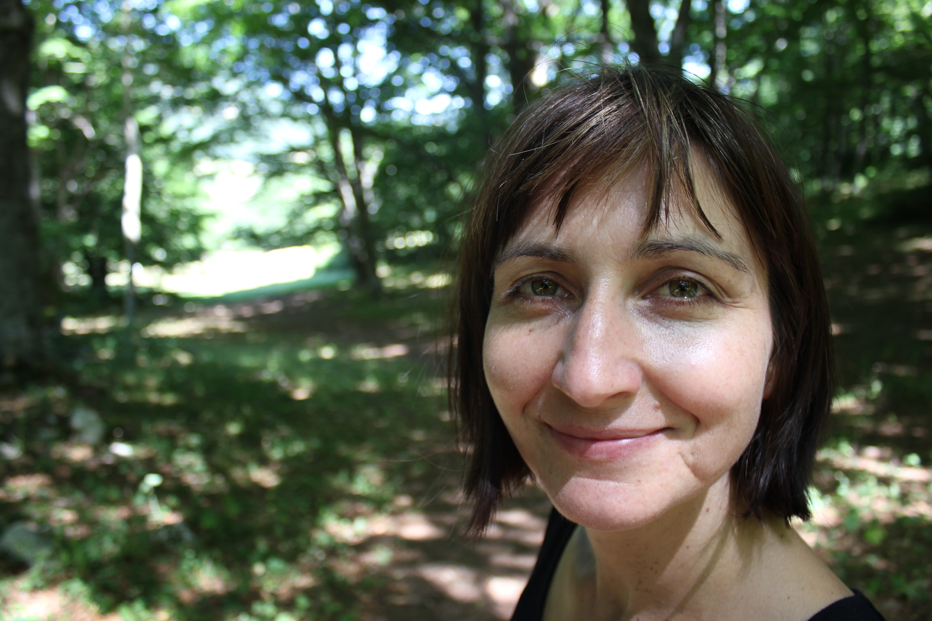
Jess has been working in documentary film making as a researcher, writer and director for over 15 years. Her work spans a variety of projects including television series and one off documentaries, festival features, online films, music videos and public art installations.

Her first independently produced documentary feature Cowboys & Communists screened at the New Zealand International Film Festival, Dok Leipzig and San Francisco Documentary Festivals, as well as several other programmed screenings. It won the prize for Best Documentary at the Kassel Documentary Festival in Germany and screened several times on ARTE across Germany and France. ‘Cowboys & Communists’ received 4 star reviews from both the Dompost and the New Zealand Herald.

Her first television documentary series, Rockquest won both the Qantas and New Zealand Television Awards for best youth programme and she was part of the award winning Sticky Pictures Arts series The Gravy for 4 seasons. In late 2008, she travelled with the Royal New Zealand Ballet on their tour to China and made an hour-long documentary Black on Red for TVNZ’s Artsville. She also directed Flight of the Conchords – A Texan Odyssey at the SXSW music festival in Texas for TV3.
As part of Oxfam International’s Sisters on the Planet series, she travelled to Bougainville and the Carteret Islands to film the story of Ursula Rakova and her efforts to relocate her people as their islands are overcome by seawater.

With her partner, Robert Appierdo she is co-director of a series of projects for Storybox including Storybox:Waharoa, a large scale outdoor documentary installation for the Christchurch International Arts Festival in conjunction with Ngai Tahu and After Light, a 14 screen work presented across 27 shipping containers for iLight Marina Bay festival in Singapore.

producer-Vicky pope
Vicky Pope has over 15 years production experience in the industry through her work as a Wellington-based film and television producer. In her early career she worked for a number of Wellington commercial production companies producing high-end TVCs and music videos before undertaking a role with the NZ Film Commission as a Development Executive.


She produced the NZFC financed short films The Graffiti of Mr Tupaia and Choice Night which both screened in numerous prestigious international film festivals including the Clermont Ferrand, London, Melbourne, Valladolid and Locarno. Graffiti also won Best Short Film Screenplay, Best Actor in a Short Film, and Best Short Film at the 2008 NZ Film and Television Awards.

Vicky also produced the independent feature documentary Trouble is My Business. Trouble premiered at the NZ International Film Festival 2008 and was theatrically released through Arkles Entertainment in New Zealand in 2009 .During this period she also Executive Produced 5 short films for the NZ Film Commission including Meathead which premiered in official competition in Cannes in 2011. Vicky was also nominated as “Woman to Watch” at the 2008 WIFT NZ awards.

In 2009 she also delivered the TV documentary Flight of the Conchords:On Air for Prime TV in NZ. The documentary has sold to HBO (US), BBC (UK) XYZ Networks (Australia) and Sveriges TV (Sweden).

Most recently she has produced the NZ comedy feature film Two Little Boys starring Bret McKenzie (Flight of the Conchords) and Hamish Blake (Hamish & Andy). The film was directed by award winning director Robert Sarkies (Scarfies, Out of the Blue) and premiered at the Berlin Film Festival in 2012.

editor-annie collins
Annie Collins is an award-winning editor who has been working in the New Zealand independent film industry for over 30 years. She has worked extensively in documentary with some of NZ’s most highly regarded filmmakers and her credits include some of the country’s most iconic and historically important films such as Merata Mita’s Patu! covering the civil disobedience during the Springbok Tour of 1981 and Barry Barclay’s The Neglected Miracle which deals with questions of responsibility for crop and genetic plant resources.
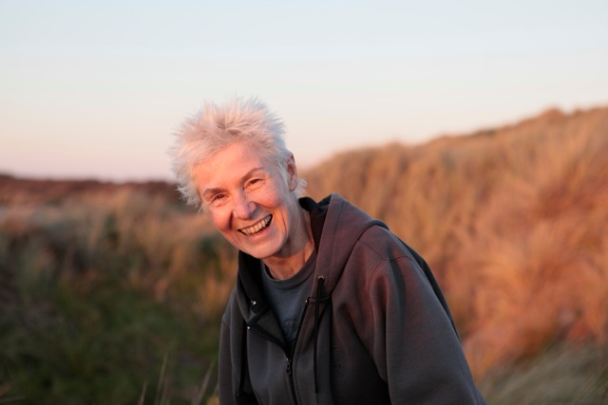

Annie’s accolades include Best Editing (for Scarfies and Two Little Boys with Robert Sarkies) at the NZ Film and TV Awards in 2000 and 2012 respectively and Best Editing-Documentary and Factual for The Waterfall at the Aotearoa Film and Television Awards in 2011. Annie’s work as Assembly Editor on Lord of the Rings: Return of the King contributed to the 2004 American Cinema Editors awards and the Academy Award for Editing (Jamie Selkirk) 2004.

credits

Card 1
Directed by Jess Feast

Card 2
Producer
Vicky Pope

Card 3
Editor
Annie Collins

Card 4
Cinematography
Ari Wegner, Gareth Moon and Hamish Waterhouse

Card 5
Sound Design
John McKay

Card 6
Composer
David Long

Rolling Credits

Additional Photography Matty Warmington
Aline Tran

Production Sound Jess Feast
Nic McGowan
Nicolas Widfeldt

Editorial assistants Darren Foster
Gareth Moon
Hamish Waterhouse
Mike Townsend

Digital Conform Spooky Pictures

Edited on Avid with the kind support of Richard Kelly and Atomise Ltd

Re-recording Mixer John McKay
Foley Artist Robyn McFarlane
Foley Studio Underground Sound Ltd
Edit & Mix Facility Outpost Ltd

Post Production Facility Park Road Post Production
Head of Production Dean Watkins
Post Production Producer Nina Kurzmann
Post Production Editor Tim Willis
Colourist Matthew Wear
Tape room Supervisor Victoria Chu
Tape Operator Stephen Duburguet
Tape room Operator - Digital Mastering Michael Harris
Head of Technology Phil Oatley
Digital Lab Manager Amy Shand
Lead Data Wrangler Natalie Best
Data Wranglers Clare Brody
Joyce Cristal
Wattana Moeung
Projectionist Paul Harris

Visual Effects Greg Pawsey
Graphic Design Shayna Quinn

MUSIC

“Lux Aeterna” “Prayer”
From “Requiem for my Friend” From “Requiem for my Friend”
Composed by Zbigniew Preisner Composed by Zbigniew Preisner
Published by Chester Music Ltd/ New Music B.V. Published by Chester Music Ltd/ New Music B.V.
Recording used by kind permission of New Music B.V. Recording used by kind permission of New Music B.V.
All rights reserved All rights reserved
www.preisner.com www.preisner.com

“The Maze” “Pearly Shells”
Composed by Peter Scholes (Control) Written by W Edwards & L Pober
Courtesy of Mana Music Productions © Criterion Music Corporation
Administered by J. Albert & Son Pty Ltd

“Sleep Sweet Sleep” “Thanks Be To God”
Composed and Orchestrated by John Charles Composed by Chris Skinner SM
Performed by members of the NZSO Recording used by kind permission of Chris Skinner
Conducted by David Fraser All Rights Reserved
Recording used by kind permission of John Charles
All rights reserved

“Happy Birthday To You” “Take O Take Me As I Am “
Mildred Hill / Patty Hill From the collection “Come All You People
© 1935 Summy Birchard Inc. Words and Music by John Bell
Licensed by EMI Music Publishing Australia Pty Ltd. © 1995 Wild Goose Worship Group

“Alleluia”
From the collection “Sent By The Lord”
Wild Goose Publications 1991
Words and Music South African Traditional

Archive footage of the Home of Compassion from “Unto These Least” (1956). Material preserved and made available by The New Zealand Film Archive Nga Kaitiaki O Nga Taonga Whitiahua. Courtesy of Pacific Films Collection and the Sisters of Compassion.

NZFA logo

Thanks to:

David Binks
Kristen Neely
Mary Geddes
Noelene Pilcher
Sister Josephine Gorman
Sister Sheila McGrath
Sister Cecilia Scanlon
Heng Ang
Annie Farrant
Peter Conaghan
John O’Neill
Giotto Appierdo
Sophia Brown
Blake Bridges
Kate Smith
Rowan Tanner
Denise Blewman
Micheline Evans
Gordon Hays

Amy O’Connor
Juliette Veber
Pietra Brettkelly
Vicky Powell
Rhian Sheehan
Kevin Armstrong
Johan Bekker
Mark Jackson
Sima Urale
The Film School
Shara Hudson
The NZ Film Archive
David White
White Balance Pictures
Chris Skinner
Mark Callaghan
Laurence Aston
Chris Gough
Phil Burton
Ray Beentjes
Chris Todd
Matt Emery
Sister Margaret Mary Murphy
Sister Cabrini Tu’ipulotu

Special thanks to:

Rob Appierdo
Robert Sarkies
Cheryl Cameron
Gary Tennant
John Feast
Deb Feast
Liz Appierdo
Laurence Alexander
Richard Kelly
Vicki Jackways and the team at Park Road Post Production
Naomi Wallwork
Graeme Mason
Bill Gosden
Sister Margaret Anne Mills
And all the Sisters at the Home of Compassion in Island Bay

Very special thanks to:

Sister Loyola Galvin

Thanks to our sponsors:

Logos: Park Road Post, Rubber Monkey

In association with the Independent Filmmakers Fund

CNZ logo

Produced in association with The New Zealand Film Commission

Film Commission logo AND the combined NZ Lotteries logo

Filmed on location at The Home of Compassion, Wellington, New Zealand

A POP Film and Visual Feast Production

This film including its soundtrack is protected by the copyright laws of New Zealand and all other applicable laws worldwide. Any unauthorised reproduction, distribution or exhibition of this material for any purpose whatsoever is a breach of copyright and will result in civil and criminal prosecution.

© POP Film Ltd 2013
ALL RIGHTS RESERVED

